**How we forecast the weather**

**We observe, we analyse, we predict**

The purpose of Weather forecasting is to predict the future state of the weather at a given location so that we can plan our activities and avoid them being interrupted by weather conditions.

Since time immemorial people have attempted to predict the weather, with success in many cases, using a variety of methods, including appearance and/or behaviour of certain animals, plants and insects, the condition of the sky or changes in wind, etc.

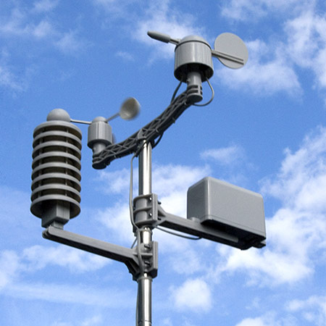In our time, weather forecasting is based on the scientific understanding of physical processes in the atmosphere. The processes in the atmosphere (air motion, condensation, rain formation, etc)) obey laws of physics.

In order to make a weather forecast for a specific location in our country, we have to:

1. collect data over a wide area, on the current state of the atmosphere (temperature, air pressure, wind speed and direction, cloud type, height and amount, ... observed at the earth’s surface and at different levels of the atmosphere by instruments carried by hydrogen filled balloons);
2. Analyse the data and use it to predict how the atmosphere will evolve.

Analysing the data involves, for example:

1. Determining areas of rain and dry weather and whether these areas are moving away from or towards our area.
2. 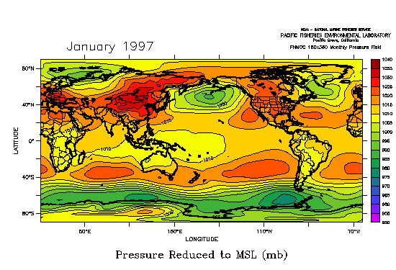Locating areas of low and high pressure and how these are developing (filling of low pressure or intensifying of high pressure). Low and high pressure areas help to determine where air is rising (in a low pressure) and where air is sinking (in a high pressure). Rising air leads condensation of water vapour to form clouds, and if the air rises over a deep layer of the atmosphere, the clouds will be thick and will give rain. Rising air over a wide area leads to a widespread area of rain which is gentle and long lasting. Sometimes there is rising motion over localised areas, giving rise to clouds of large vertical extent and thunderstorms and showers. Showers are usually heavy and of short duration.

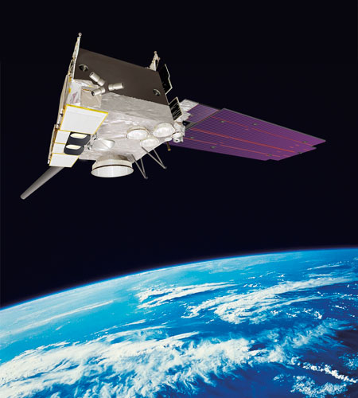To forecast the weather over our town for the next few hours it is enough to look at the sky and determine whether it is going to rain. To forecast the weather over the whole of Rwanda, for the next few hours, we can look at weather reports which are made and sent to Kigali every hour and cloud images taken by satellite. But to forecast the weather over Rwanda tomorrow we need information from a larger area extending beyond Rwanda’s borders, because the air over, say Tanzania today, may be over Rwanda tomorrow. The further in the future we want to forecast, the larger the area from which we need data (up to Atlantic and Indian oceans if we have to forecast to two or three days).

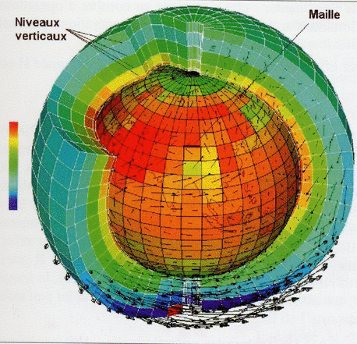Since the atmosphere obeys the laws of physics (equations of motion, equation of thermodynamics, conservation of mass, and so on), it is possible to solve the equations on a computer, using the current conditions of the atmosphere to predict the future state. Morden weather forecasting is based on computer forecast models. Describing the state of the atmosphere and determining the future state through mathematical equations on the computer requires massive computer power, and considering that there are areas where there is no data (no observing stations) means that the understanding of the current atmospheric conditions can be incomplete and hence the forecast can become less accurate as we forecast further into the future (e.g. the forecast for tomorrow is more accurate than the forecast for three days from today)

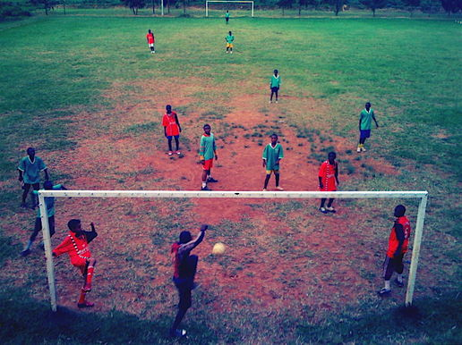There are many uses of weather forecasts, for example, weather warnings are important for protecting life and property, forecasts of temperature and precipitation are important to agriculture, and therefore to traders within commodity markets. Temperature forecasts are also useful for utility companies (water and electricity) to estimate demand over coming days. For the general public weather forecasts can be used o determine what to wear, or whether or not to carry an umbrella on a given day. Outdoor activities (like sports or public transport) can be adversely affected by heavy rain, hence forecasts can be used to plan ahead and avoid disruption.